Week 2
Functional Programming using
map()
1.Running Sum of 1D Array
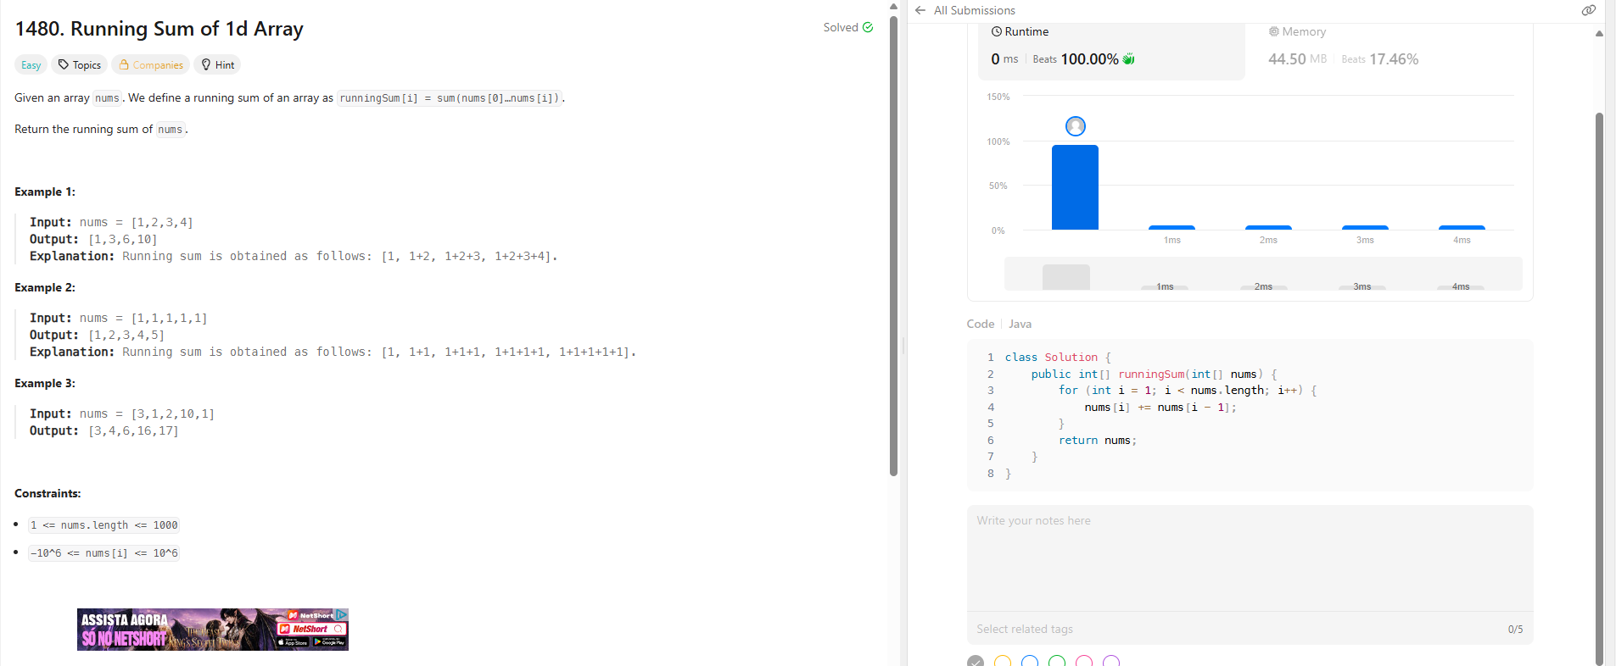
2.Shuffle the Array
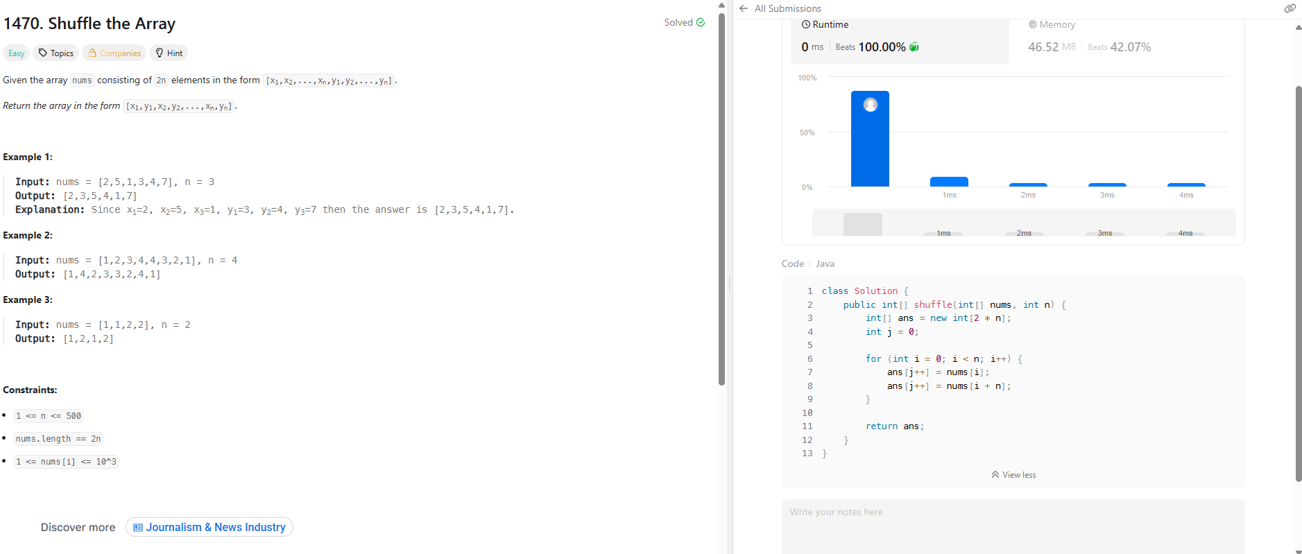
Functional Programming using
filter()
1.Remove Element
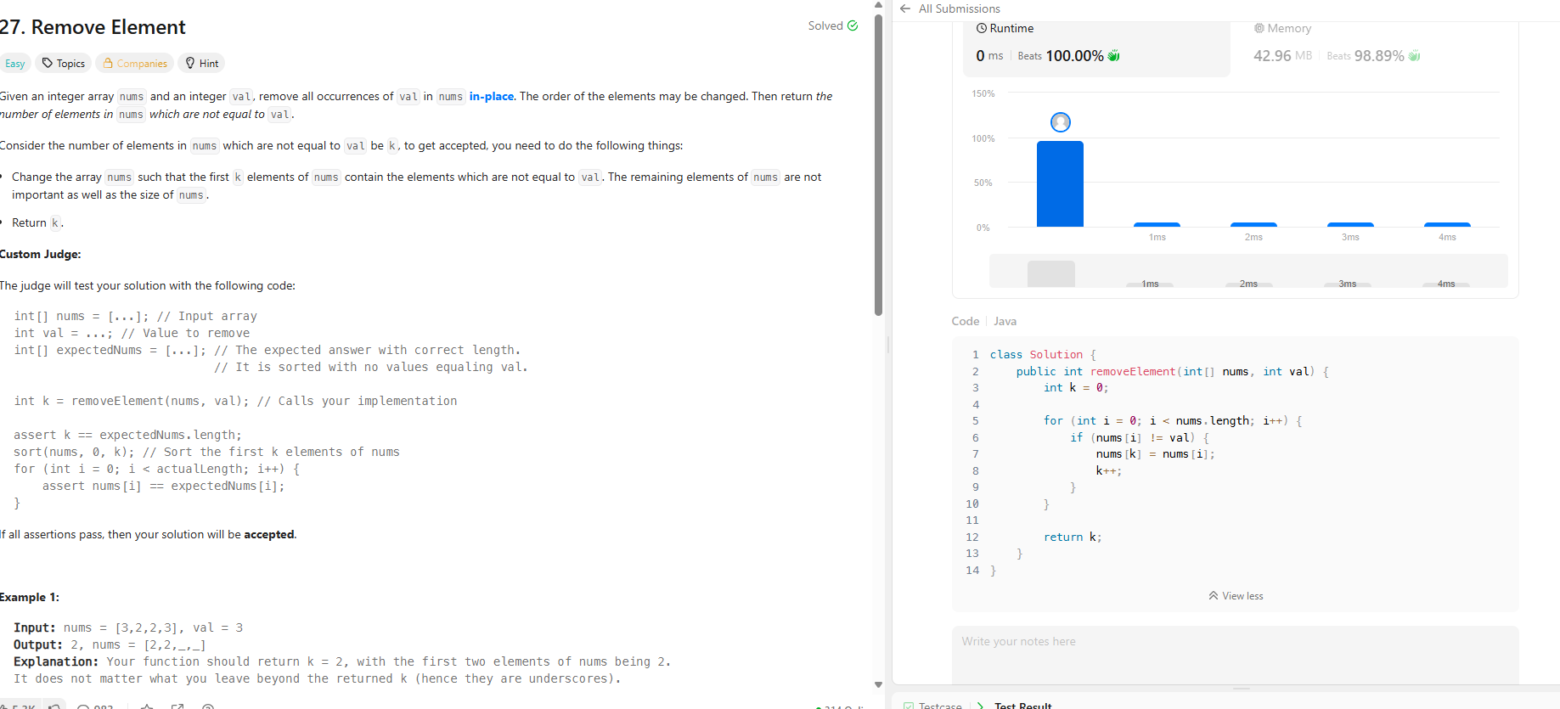
2.Remove Duplicates from Sorted Array
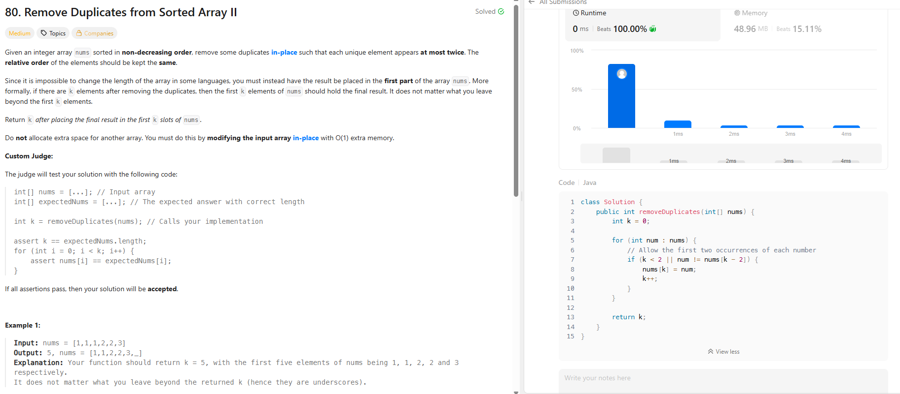
Functional Programming using
reduce()
1.Maximum Subarray
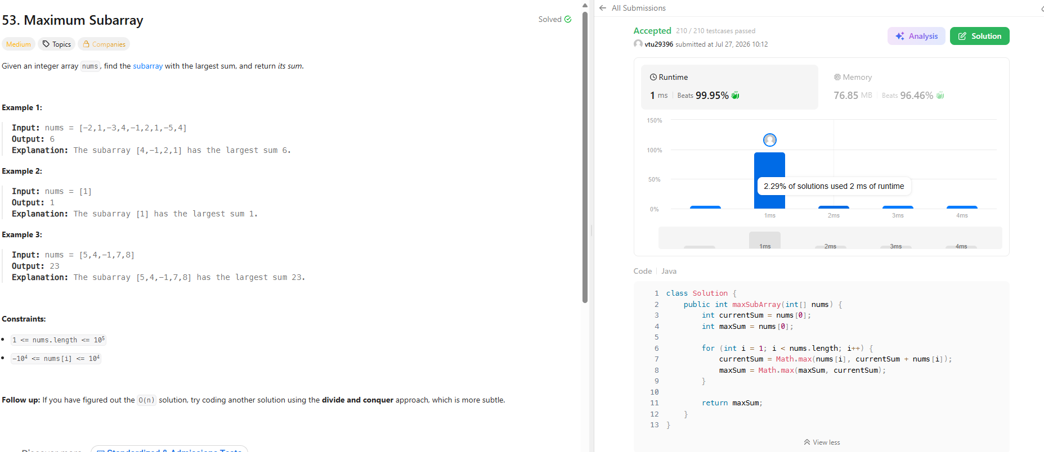
2.Find the Highest Altitude
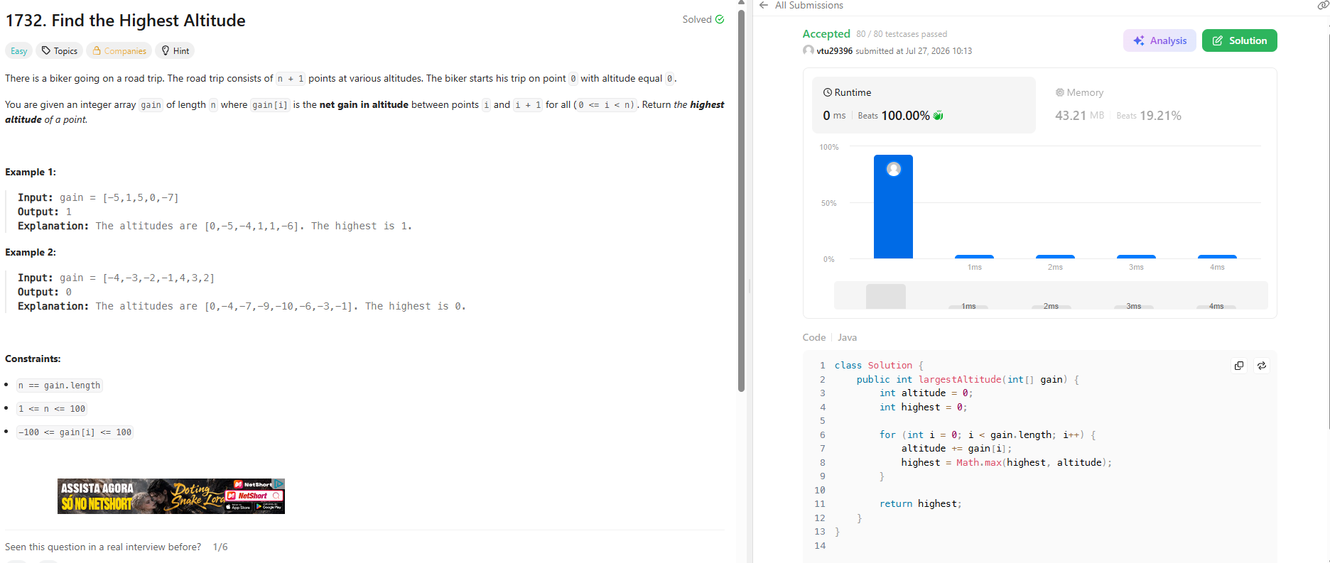
Stream & Pipeline Processing
1.Group Anagrams
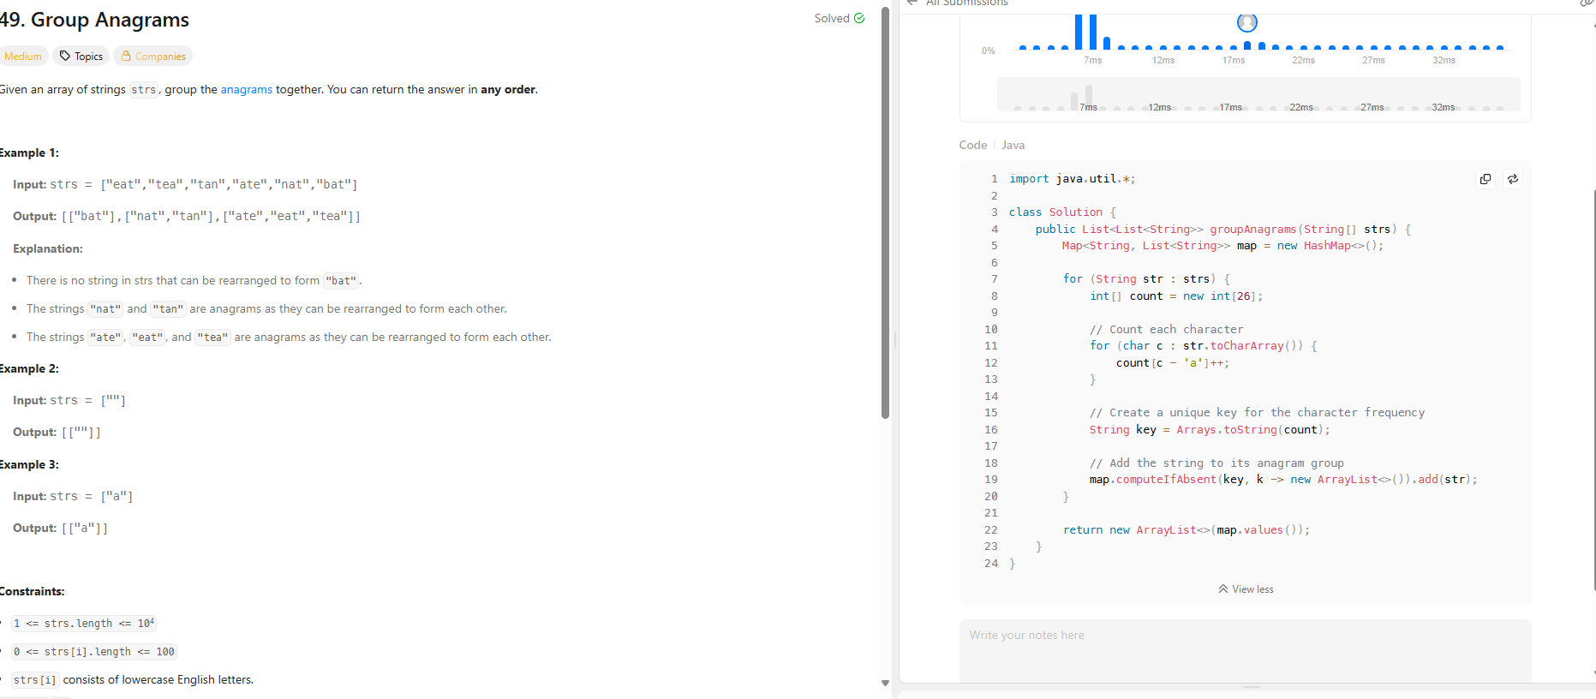
2.Top K Frequent Elements
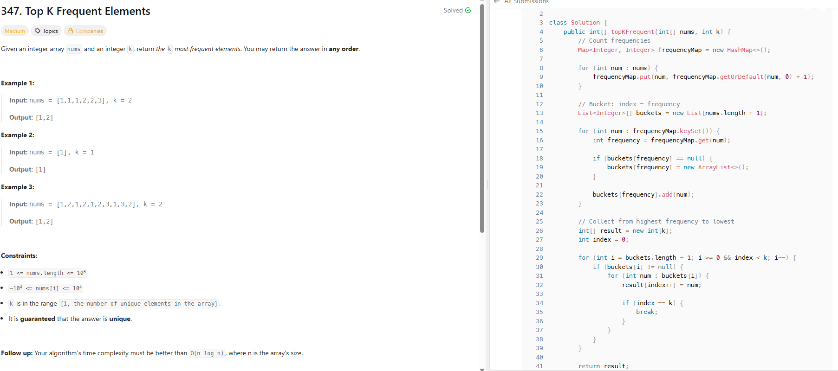
Stream API & Collection Processing
1.Java Dequeue
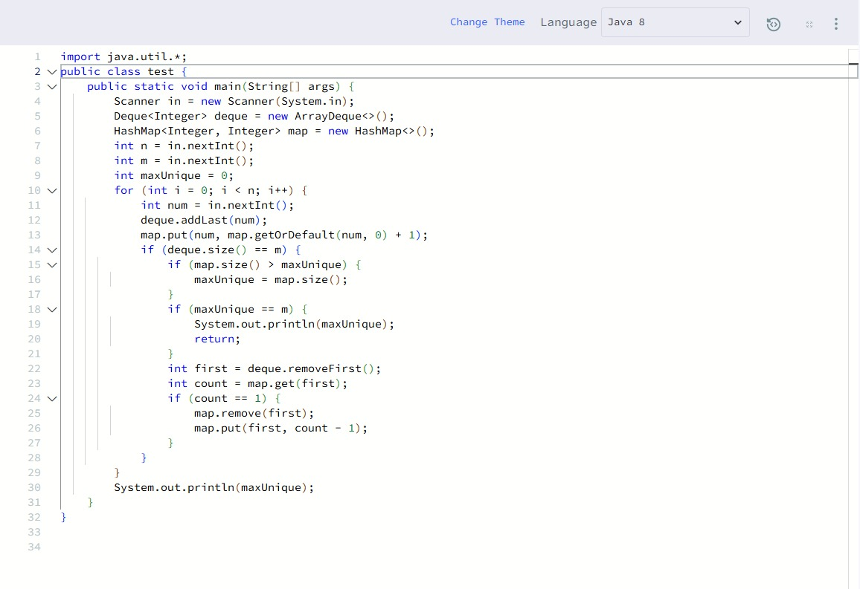
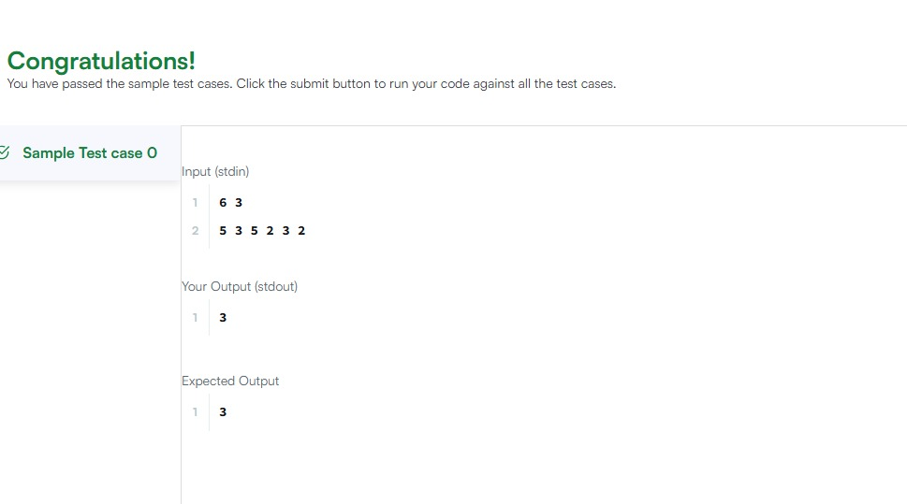
2. Java Hashset
